GEOL 551: Applied Petroleum Geology   
Assignment #2 - Due 2/11/2019

Nadima Dwihusna

Original

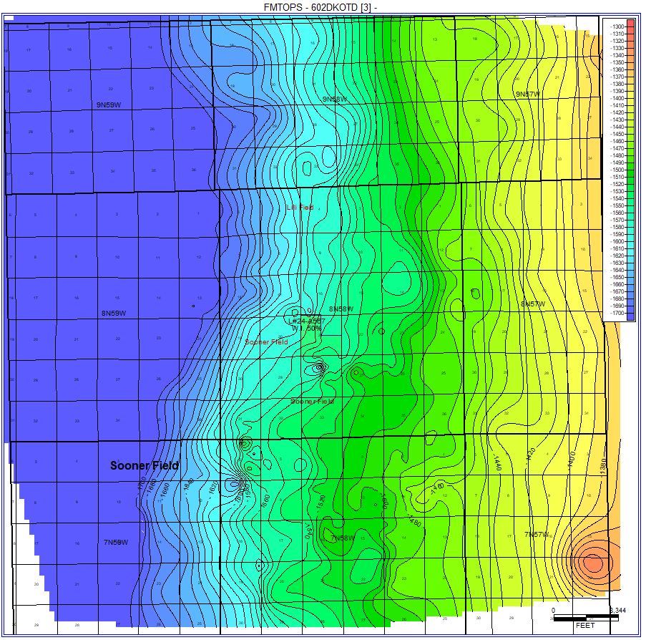

Contour Grid Edits and zoomed into the section with edited font sizes

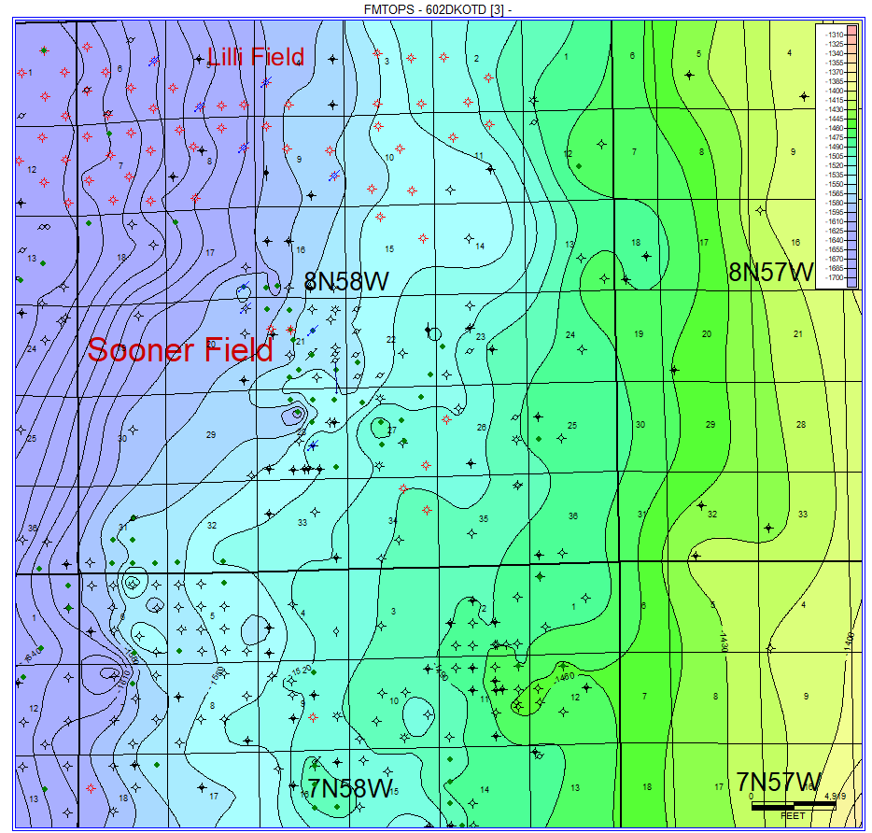

Add in the D SS Formation Tops to all wells

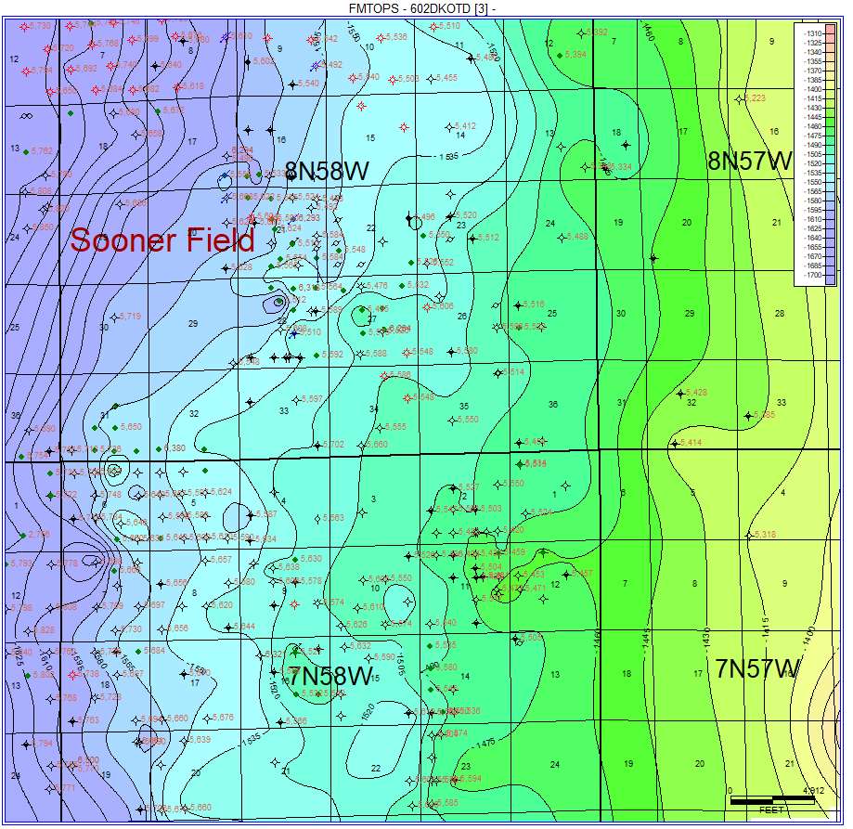

* **Homework 2**
  + 1. Add faults → where there are steep dips or nose… on east side

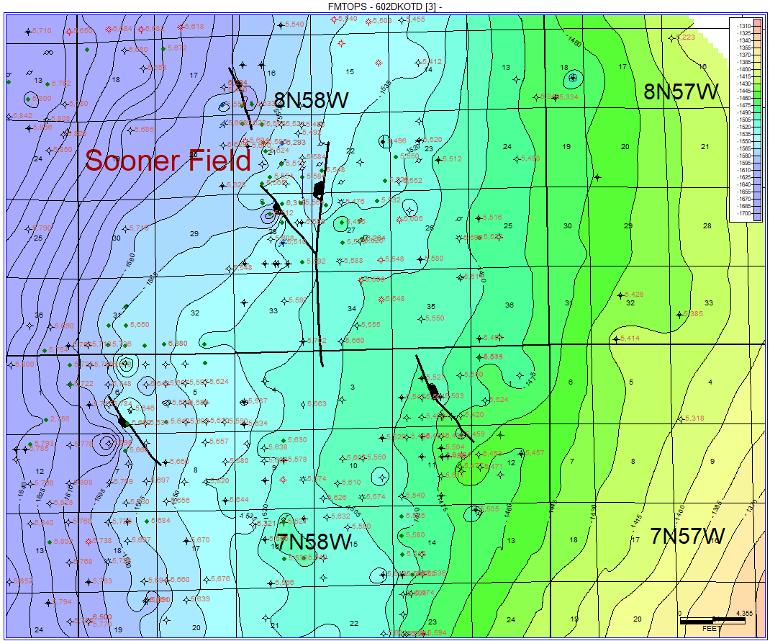

* + 2. Manipulate contour points and contour lines to look more geologically correct

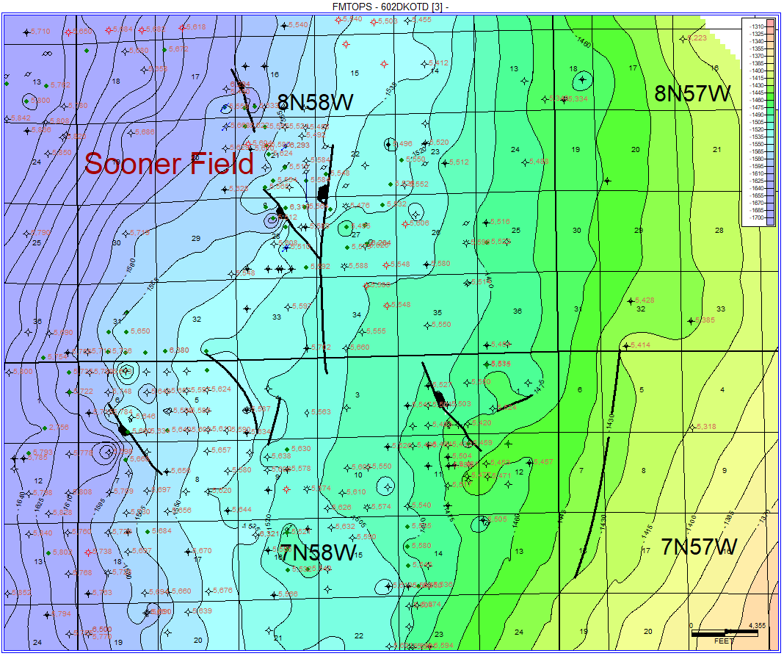

* + 3. Remake the Formation Tops 602 Dakota D3 Sandstone using Screen Limits and “use overlay contour lines”, “include Control Points” and the “Highly Connected Features (Least Squares)” Method
* Maps of added faults and alteration:

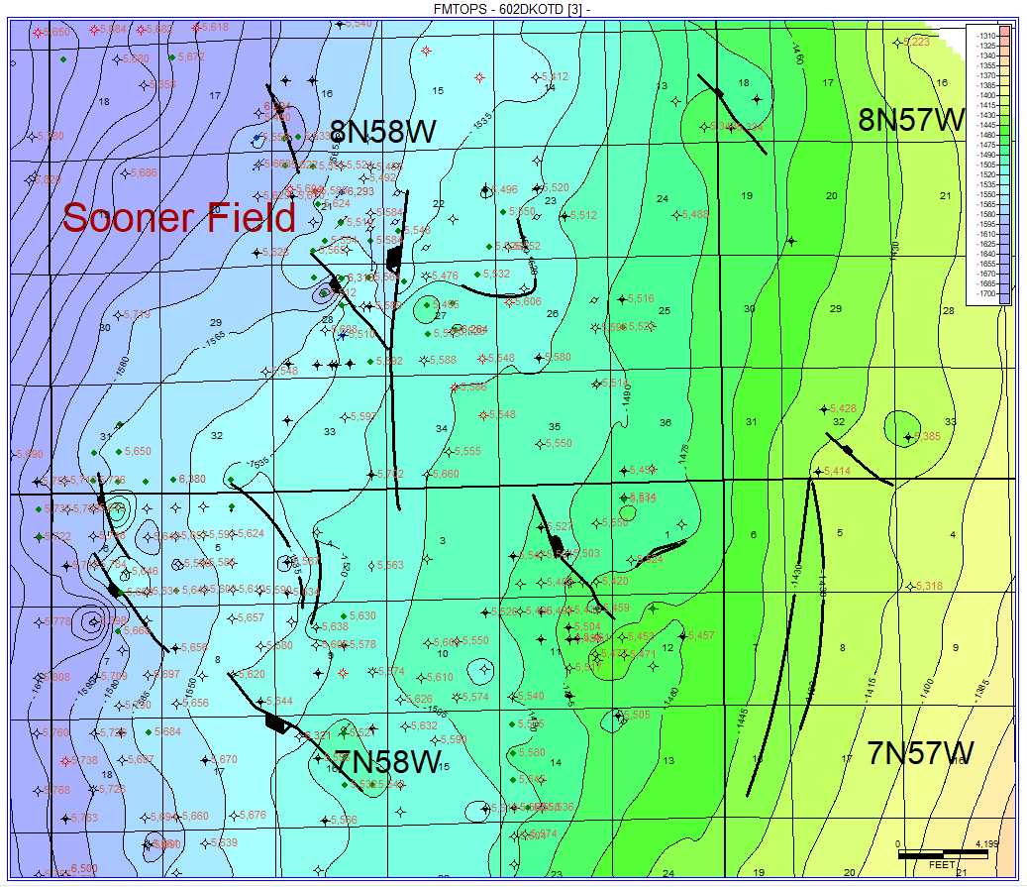

* + Make sure to be clear on where you changed it. Before After
  + After faults and contour alteration:
  + 